

***Airlines Reservation System***

**Programming Language || LAB**

CSE215L

Section: 10

Semester: Spring-23

Submission Date: 06-06-2023

**Submitted by:** **Submitted to:**

**Group-** 4 Monamy Islam

**Group members:**

* Imam Hossain Rakib **ID**- 213213042
* Payel Das **ID**- 2132492642
* Towhidul Islam **ID**- 2212172642
* Raidah Binte Raihan **ID**- 2212484042
* Afia Tabassum **ID**- 2221891042
* **UML Diagram :**

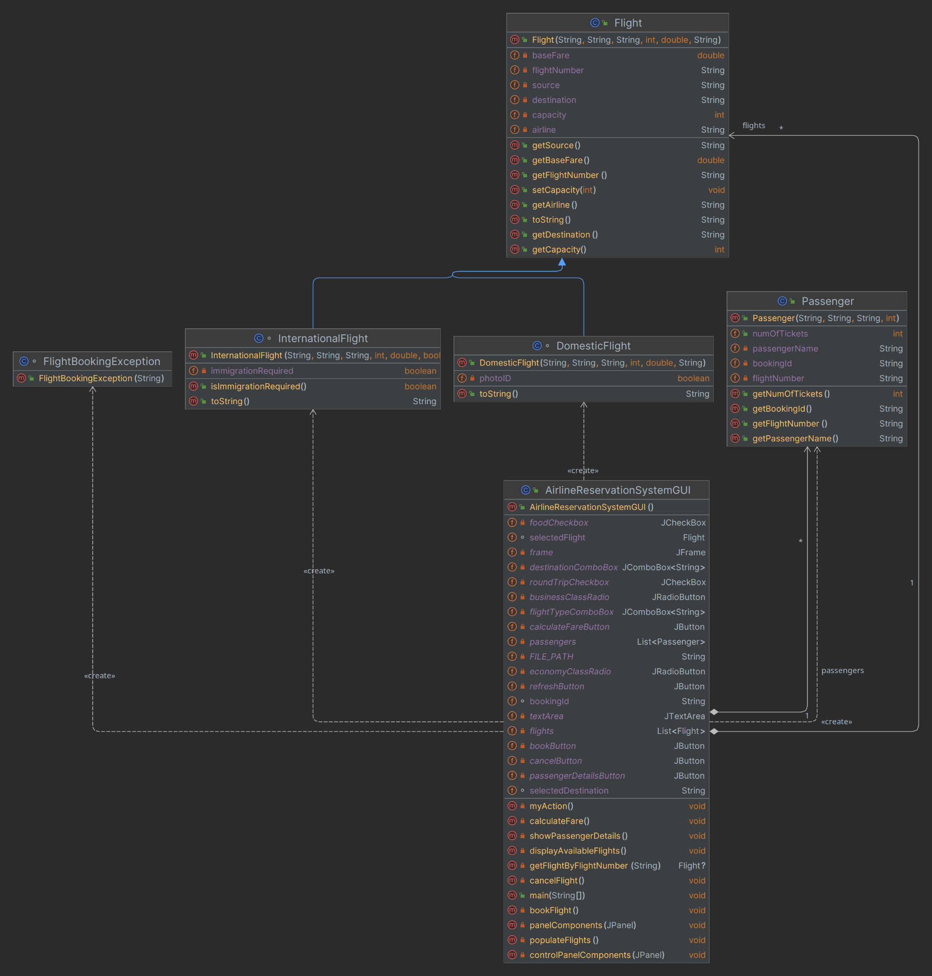

* **Project Features :**  Our project is about airlines reservation system.By this system any user can book their flight.

**1. Flight Details:** The system shows information about flights such as destination,capacity,airline name.

**2. Booking Flight:** The system lets the user to book a flight among the available flights.Here user can choose either they want to take a international or domestic flight.The system then lets the user choose their desired destination.User can also choose their seat types-Economic or business.User can even book a up-down flight ticket.They also can choose if they want to book the flight with food service.

**3. Fare calculation:** User can see how much their ticket costs based on their selected ticket type.

**4. Passenger details:** User can see the details of their booking.

**5. Flight Cancellation:** User can cancel their booked flight by inputting their flight number.

* **Description of each class :**

The source code for this system contains total five classes.Below is a detailed description of how each class works-

**1. Flight class :** This class has total 8 methods and one constructor.This class takes input for flight number,source,destination,capacity,basefare and airline.The parameterized constructor takes value for each instance and assigns them.

i. **getFlightNumber() :** This returns a string type value of flight number.

ii. **getSource() :** This returns a string type value of source.

iii. **getDestination() :** This returns a string type value of selected destination.

iv. **getCapacity() :** This returns an integer type value of capacity.

v. **setCapacity(int capacity) :** This method accepts an integer type value and sets it to capacity.

vi. **getBaseFare() :** This method returns a double type value of basefare.

vii. **getAirline() :** This method returns a string type value of airline.

viii. **toString() :** This method returns a string type printing line.

**2. DomesticFlight :** This class also extends Flight class.It has one constructor and one method.

i. **toString() :** This is an overriding method of Flight class.It calls the Flight class toString method and adds another printing line to it.

**3. InternationalFlight :** This class also extends Flight class.It has one constructor and one method.

i. **isImmigrationRequired() :** It returns a boolean type value of whether immigration is required or not.

ii. **toString() :** This is an overriding method of Flight class.It calls the Flight class toString method and adds another printing line to it.

**4. Passenger :** This class has total four methods and one constructor.This class takes input for booking id,flight number and passenger name.The parameterized constructor takes value for each instance and assigns them.

i. **getBookingId() :** This returns a string type value of bookingId.

ii. **getFlightNumber() :** This returns a string type value of flightNumber.

iii. **getPassengerName() :**This returns a string type value of passengerName.

iv. **getNumOfTickets() :** This returns an integer type value of the number of tickets the passenger has booked.

**5. FlightBookingException Class :** This is a custom exception class.Hence it extends the exception class.It has only one constructor that takes string as input and pass it to the super class constructor.This class has no methods.

**6. AirlineReservationSystemGUI :** This class is our main class that contains main method.This class has total 11 methods.

i. **main(String[] args) :** This method sets up a frame and adds panels to the frame.It calls two methods - *panelComponents*(panel) and *controlPanelComponents*(controlPanel) where it sends two JPanel class objects panel and controlPanelComponents as parameter.Then this method sets the frame visibility to true.Then it creates an object for AirlineReservationSystemGui class and calls the myAction() method of this class using this object.

ii. **panelComponents(JPanel panel) :** This method takes a JPanel class object as input.This method sets up the components for this particular JPanel object.This method sets up the panel layout to borderlayout.

This method creates a textArea and makes it non-editable and adds the textArea to the center of the panel.

Then it sets a JLabel called planeLabel and sets it icon to an image at a specified location.The planeLabel is then added to the east of the plane.

This method then creates a separate JPanel called buttonPanel and adds three JButton to the buttonPanel.Then adds the buttonPanel to the south of the main panel.

iii. **controlPanelComponents(JPanel controlPanel) :** This method takes a JPanel class object as input.This method sets up the components for this particular JPanel object.This method sets up the controlPanel layout to GridLayout with 5 rows and 2 columns.

This method creates a JLabel object ‘destinationLabel’ with the text “Destination” and creates a JComboBox object ‘destinationComboBox’ with some destination options.This method then adds the JLabel and JComboBox object to the controlPanel.

This method again creates a JLabel object ‘flightTypeLabel’ with the text “Flight Type:” and creates a JComboBox object ‘flightTypeComboBox’ with two flight type options.This method then adds the JLabel and JComboBox object to the controlPanel.

The method then creates a JLabel object called ‘classLabel’ and JPanel object ‘classPanel’ and sets it layout to a left aligned FlowLayOut.Then it creates two JRadioButton objects ‘economyClassRadio’ and ‘buisnessClassRadio’ with specified labels.It then creates a ButtonGroup object called classGroup and adds the JRadioButton object to it.Then adds the radio buttons to the classPanel and adds the classPanel and classLabel to the controlPanel.

This method then creates a JLabel object ‘optionsLabel’ and JPanel object ‘optionsPanel’ and sets it layout to a left aligned FlowLayOut.Then it creates two JCheckBox object and adds them to the optionsPanel.Then adds the optionsLabel and optionsPanel to the controlPanel.

Furthermore it creates two more JButton ‘refreshButton’ and ‘PassengerDetailsButton’ and adds them to the controlPanel.Then initializes two arrayLists flights and passengers.

iv. **myAction() :** This method sets up action listeners for the button created in the GUI.

This method adds ActionListener to the ‘bookButton’,’cancelButton’,’calculateFareButton’,’refreshButton’,

’passengerDetailslsButton’.The method is written in a way that when these buttons are clicked a method is called specified for that button.Those method performs designated tasks for each button.

v. **populateFlights() :** This method adds flight information to the flights array based on the flight type chosen by the user.It then adds the destinations to the destinationComboBox and calls the displayAvailableFlights method.

vi. **displayAvailableFlights() :** This method displays information about the flight the user has chosen.

vii. **bookFlight() :** This method takes passengers name and the number of tickets they want to book and books the flight for them.It also saves the passengers information to the passengers array and writes them in a text file.

viii. **cancelFlight() :** This method cancels a flight by taking booking ID of the passenger as a input.It also throws a FlightBookingException if user inputs invalid booking ID.

ix. **calculateFare() :** This method calculates the fare of the ticket based on the user’s choice of economy,business,round-trip and food.

x. **showPassengerDetails() :** This method checks if a booked ticket has been cancelled or not.Then it saves the passengers informations to an object and displays them when the Passenger Details button is clicked.If a specified flight is not booked by any passenger yet it shows no passenger information with a message.

xi. **getFlightByFlightNumber(String flightNumber) :** This method takes the passenger’s booked flight number as an input and if the flight number matches with one of the stored flight numbers in flights array the method returns a Flight class object.Otherwise it returns null.

* **Application of project :** The system can be used as a ticket booking system for airlines services.The passenger will be able to see the flight information and book the flight ticket for their desired destination.

* **Limitations :** The system sometimes does not show the expected

output while cancelling a flight.Hence,the passenger details button does not work expectedly.While running the system the compiler might not work on the methods simultaneously.This is why this problem arises.

* **Future Work :** The system can be upgraded with more advanced level features in future.It can be used as an online airline flight booking process in real world scenerio.We can make this system more accurate by using MYSQL.We can also connect it to a online server and publish it as a website for flight bookings.